🏦 Project: BankSight AI — Agentic Banking Analytics Assistant
What It Is
A conversational AI agent that acts as a smart banking data analyst — it takes natural language questions, queries structured banking data (credit card spend, churn, customer scores), generates insights, and delivers automated reports. Essentially, it combines your SAS/SQL data expertise with Claude Code's agentic capabilities.
"Show me top 10 churned customers this month with their spend trend" → Agent queries data → Cleans & analyzes → Returns insights + auto-generates a Power BI-ready report.

🏗️ Architecture
User (Natural Language Query)
↓
Claude Code Agent ←── CLAUDE.md (project instructions)
↓
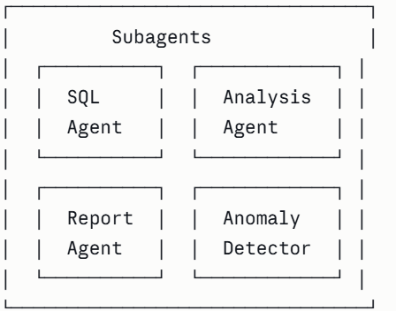
↓
SQLite / CSV Dataset (mock banking data)
↓
Output: Insights + Excel/PDF Report + Power BI Dashboard

📅 4-Week Build Plan
Week 1 — Data Foundation
- Create a mock banking dataset (Python) simulating: credit card transactions, customer churn flags, spend categories, NPS scores, employee performance scores
- Set up SQLite database with proper schema (mirrors your real work at Moody's/Fifth Third Bank)
- Write SQL queries for: churn analysis, spend trends, top/bottom performers
- Set up the project structure with CLAUDE.md defining the project rules and data schema
Week 2 — Agentic Core (Claude Code)
- Build the SQL Agent — takes natural language, converts to SQL query, fetches results
- Build the Analysis Agent (subagent) — takes raw query results, generates insight summary
- Build the Anomaly Detector Agent (subagent) — flags unusual spend spikes or churn patterns
- Write custom slash commands: /analyze, /churn-report, /trend
Week 3 — Reporting & BI Layer
- Build the Report Agent — auto-generates Excel/PDF reports from analysis output (mirrors your current Coforge work)
- Connect outputs to Power BI with a live data refresh from SQLite
- Create a simple dashboard: Churn Rate, Spend by Category, Top 10 Customers, Anomaly Alerts
Week 4 — Polish & Documentation
- Write a proper CLAUDE.md with spec-driven development docs
- Create custom Skills for reusable analysis patterns (e.g., a churn-analysis skill)
- Record a short demo video (2–3 mins) walking through a query → insight → report flow
- Push everything to GitHub with a clean README

🛠️ Tech Stack
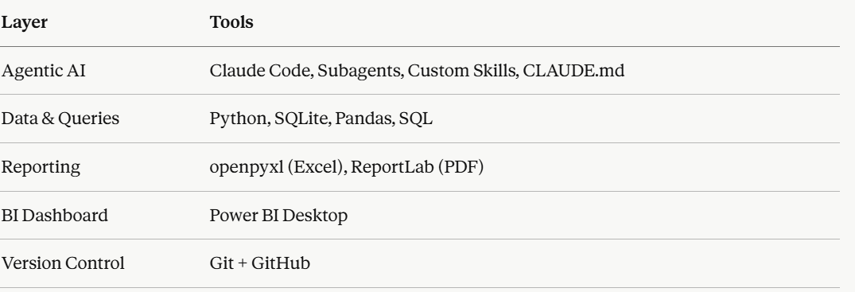
All tools you already know or have learned — no steep new learning curve.

📁 Project Structure (for GitHub)
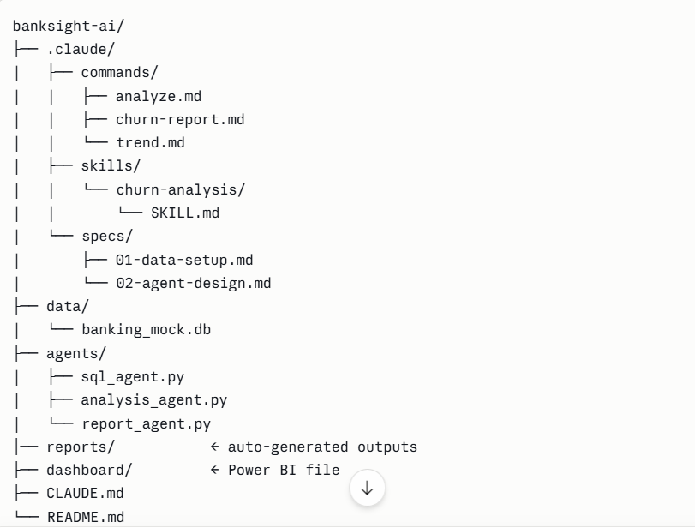

📝 How to Write It on Your Resume
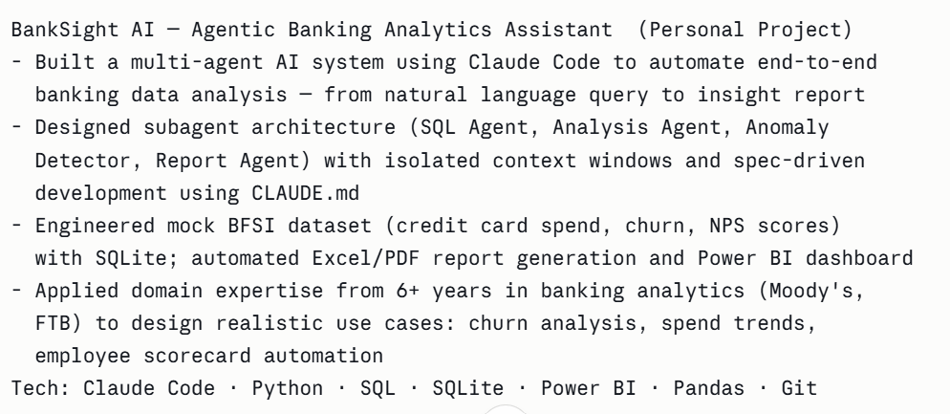
💡 Why This Project Works Perfectly for You
It hits every checkbox recruiters at Cognizant, Genpact, EXL, and Coforge's AI team will look for — banking domain credibility (not a generic project), real agentic AI architecture (subagents, skills, slash commands — not just "used ChatGPT"), and BI output (Power BI dashboard they can actually see). The fact that it mirrors work you've genuinely done at Moody's and Coforge makes it very easy to talk about confidently in interviews.
Start with Week 1 this weekend — the data setup is the most familiar part and will build momentum! 🚀

